**Experiment No.: 1 Date:28/10/2022**

**Aim:**

**CO1:**

**Procedure:**

1.select * from oxytech;

3.insert into emp (Emp_no,Emo_name,hiredate,salary) values ('101','Ramesh','1980-01-17','5000');

insert into emp values ("102","Ajay","1985-07-05","5000","500");

insert into emp (Emp_no,Emo_name,hiredate,salary) values ('103','Ravi','1981-08-12','1500');

insert into emp values ('104','Nikesh','1983-03-03','3000','700');

insert into emp (Emp_no,Emo_name,hiredate,salary) values ('105','Ravi','1985-07-05','3000');

4. alter table emp add sal decimal(7,2);

5. alter table emp drop column sal;

6. alter table emp rename column Emo_name to ename;

7. alter table emp rename to emp1;

**Output Screenshot:**

3

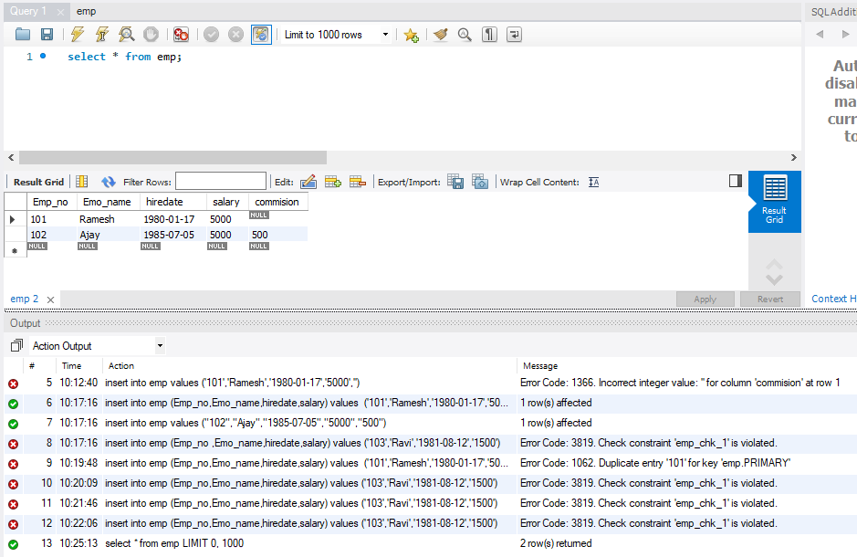

4.

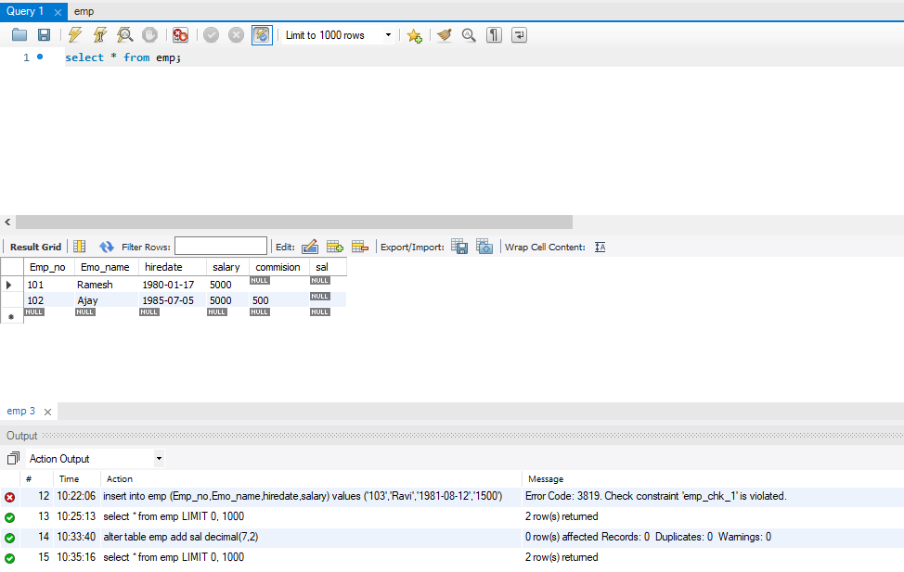

5.

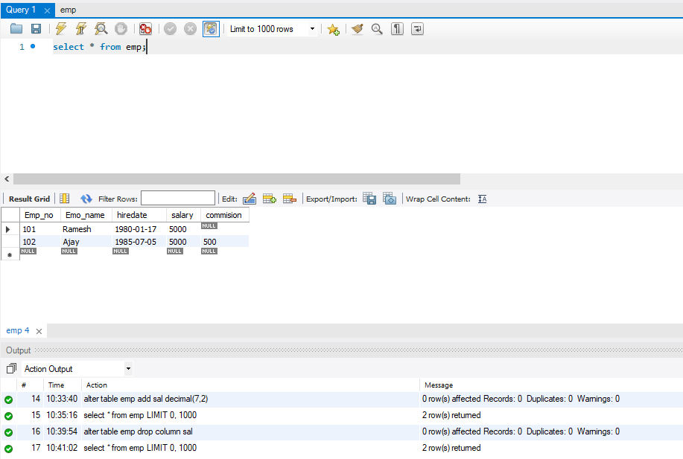

6.

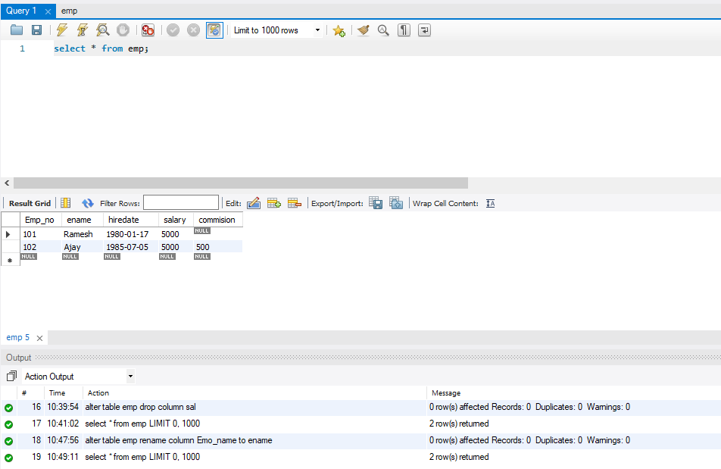

7.

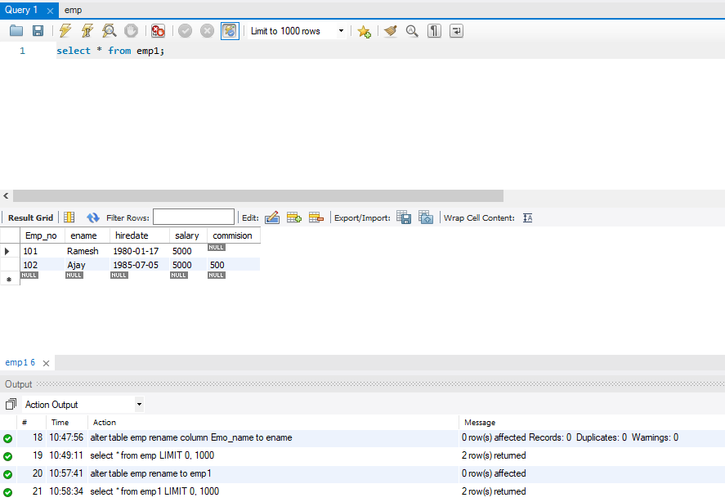

**Result**

The program was executed and the result was successfully obtained. Thus CO1 was obtained.

**Experiment No.: 1 Date:28/10/2022**

**Aim:**

**CO1:**

**Procedure:**

**Output Screenshot:**

**Result**

The program was executed and the result was successfully obtained. Thus CO1 was obtained.